

**Bahir dar university bahir dar institute of technology**

Requirements engineering assignment

By John Assefa

Id-BDU 1308160

Submitted to mr. tadele

Submission date:feb 3,2023

**Introduction**

Asana is an innovative cloud-based tool designed by the company Asana Inc. By providing a centralized platform that helps teams to collaborate and organize workflow, it has revolutionized the way project management and communication is done in modern workplaces. Basically, Asana acts like a task tracker that allows users to easily assign tasks, track progress, and maintain communication.

**History of Asana**

Asana was founded in 2008 by Dustin Moskovitz and Justin Rosenstein with a vision to create a collaborative space for distributed teams to work together more efficiently. They based their idea on the ‘Five Freedoms’: freedom from forgetting information; freedom from minor decisions; freedom from risk of miscommunication; freedom from passive waiting; and freedom from low visibility. The first version of Asana was launched in 2011 and since then has been continually upgraded to offer the best experience for both individual users and business organizations.

**Advantages of using Asana**

The main advantages of using Asana are its ease of use, cost-effectiveness and scalability. It can be used across many different devices including desktop computers, laptops, tablets, smartphones as well as through web browsers allowing easy access anywhere anytime. Plus, there are multiple features available such as templates for quickly setting up projects; color coding for better visual representation of tasks; automation capabilities; timeline view which displays an overview of current or completed tasks; calendar view which gives users a better look at when deadlines are due or events they may have added related to specific projects; reports creation modules so you can measure team performance or focus on certain aspects within your organization; notifications sent whenever anything meaningful happens to make sure your organization is always updated even if agents are on the road or away from their desks; integration with third parties such as Gmail which helps automate tedious process saving total time spent if manually done individually by each employee fieldguardianw4s7hgrzsg

**Disadvantages of using Asana**

Despite all its innovative features, Asanas does come with some drawbacks such as lack of support for Microsoft Office documents and absence of advanced analytics tools which might be needed by larger businesses who want detailed performance tracking options. Also lack of version control means once data is uploaded it cannot be undone which adds an extra layer of caution while working with valuable information.

**Installation Steps**

Asana can be downloaded directly from their official website although if you wish you can install it through other app stores available such as Apple App Store (IOS) or Google Play (Android).

To get started it requires some basic steps:

•Create/Sign up for an account

• Fill in Details about Your Organization

• Add Team Members

• Create Custom Projects/Categories

• Start Adding Tasks

**Special Features**

Aside from the above mentioned features which make this effective task manager really special are: Ability to reorder Tasks – Project members can drag individual tasks around into placement that best reflects their importance & Priority Notifications – Get notified when something new happens without sifting through all emails manually Conversation Threads – Keep track off any comments related specific tasks & much more!

**Conclusion**

In conclusion, we can say that despite having some drawbacks mainly rooted in insufficient flexibility compared to comparable applications intended for large teams or businesses due its relatively simplistic design philosophy – being easy & intuitive have made it ideal solution for small groups wishing to mostly stay informed while completing set goals but need faster responsiveness between teams than emailing would provide! Moreover constant updates keep bringing plenty new & exciting features adding further value customer experience creating long term relationship between team members who rely this app daily basis complete day today activities!

The following is the live demonstration of how asana works

1.search for asana.com

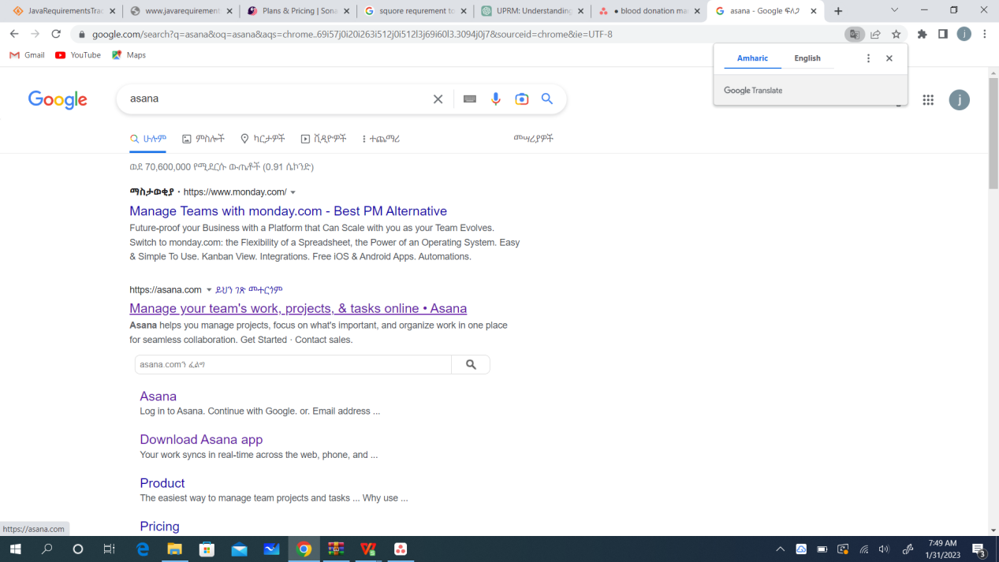2.enter website and click get started 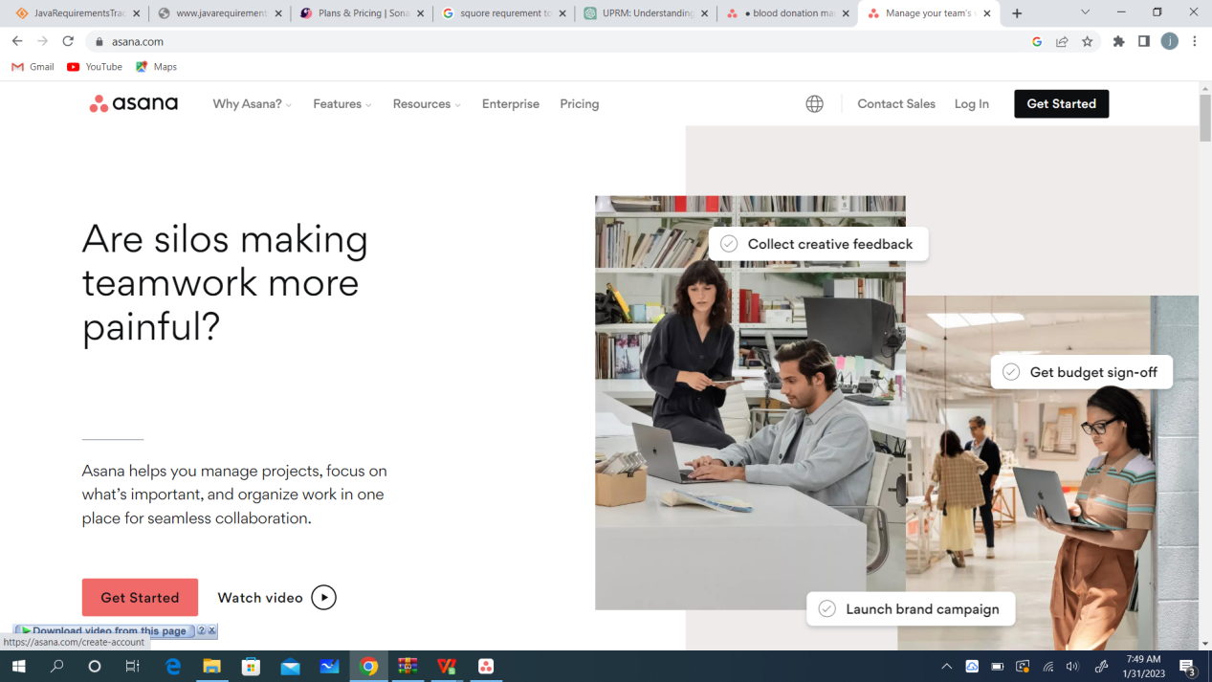

1. start signing up process by writing your email 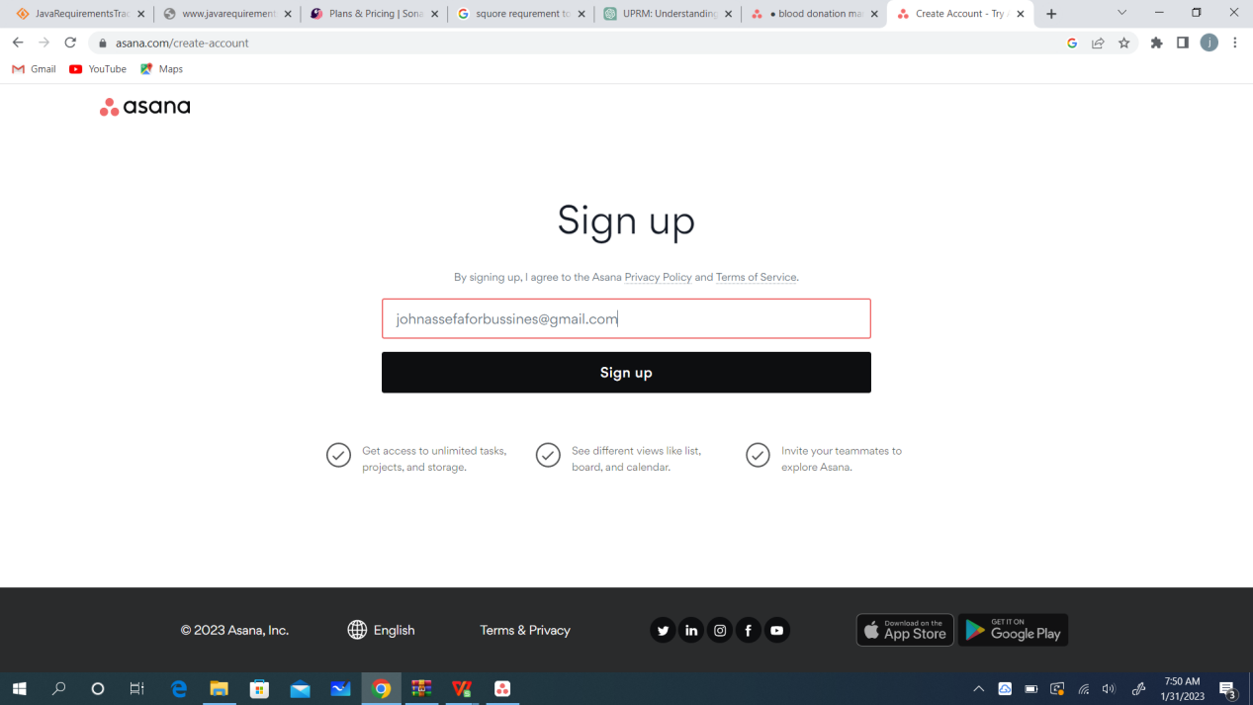
2. Verify you email 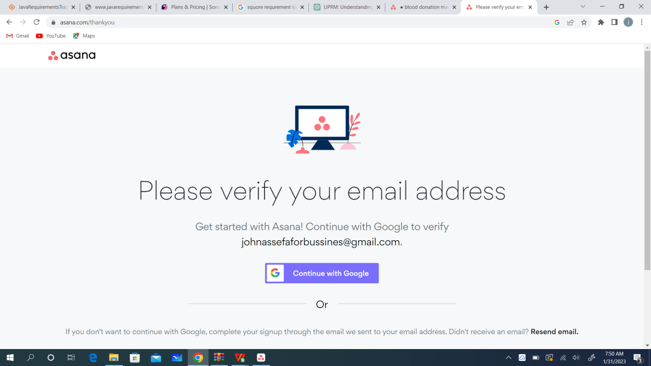5.enter your name 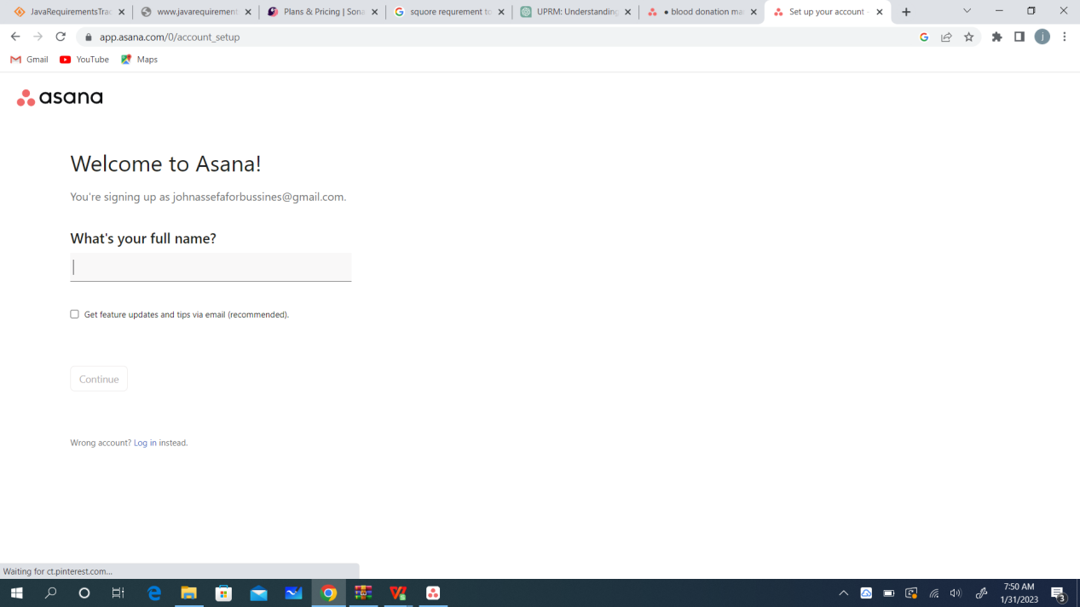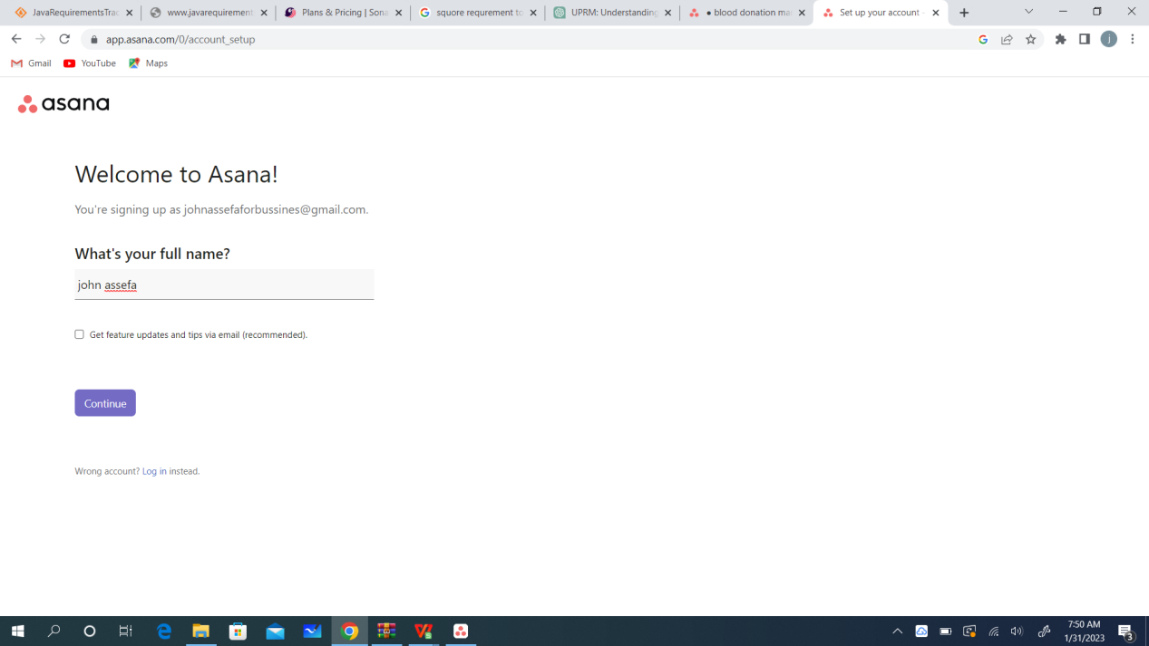6.choose your role

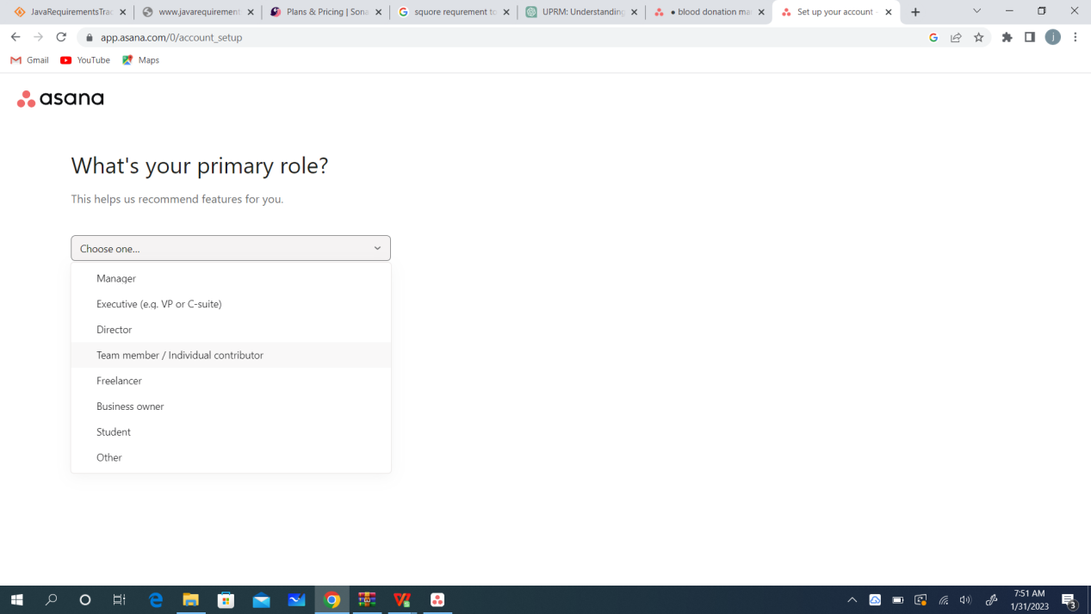

1. select your field and project type 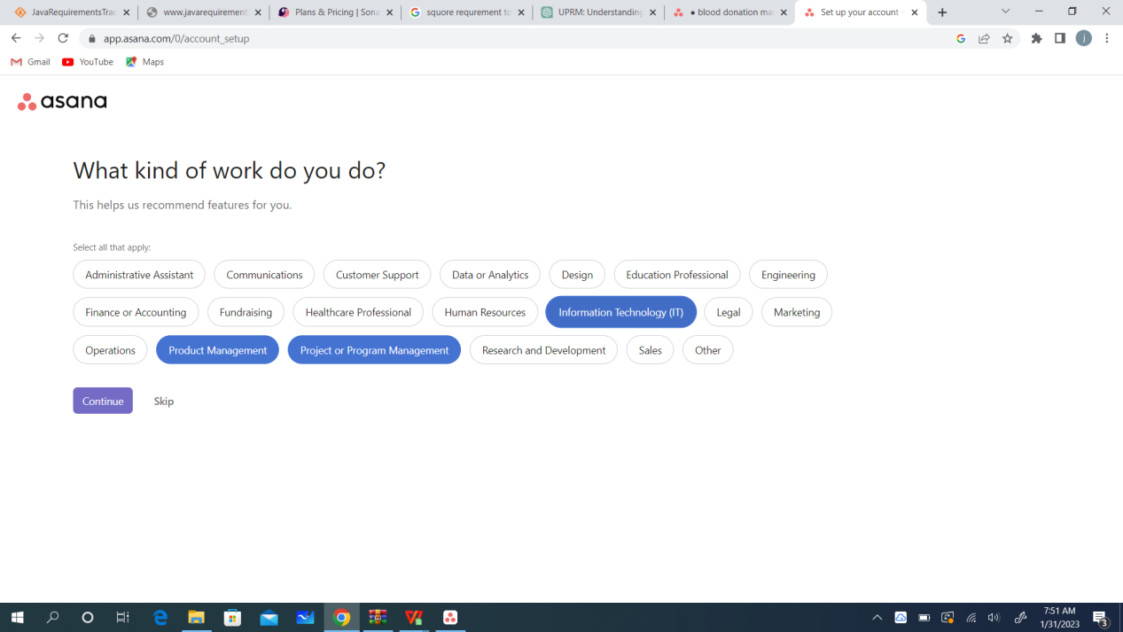
2. Select project objective 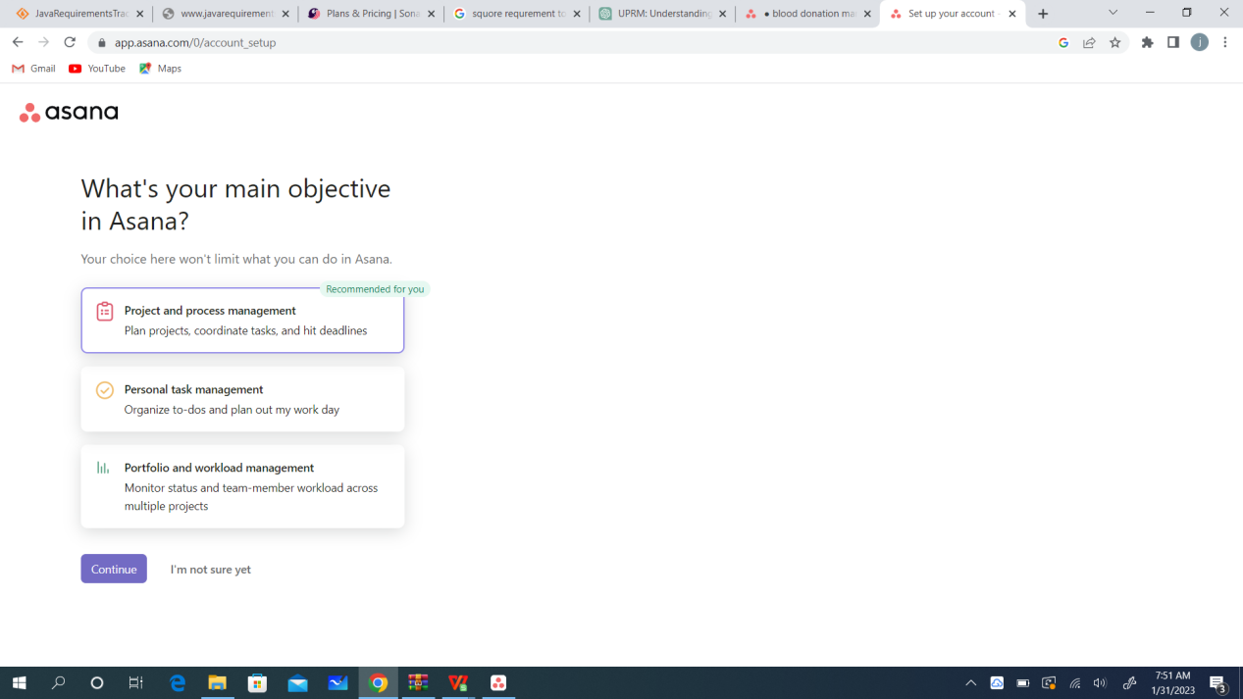
3. Enter project title

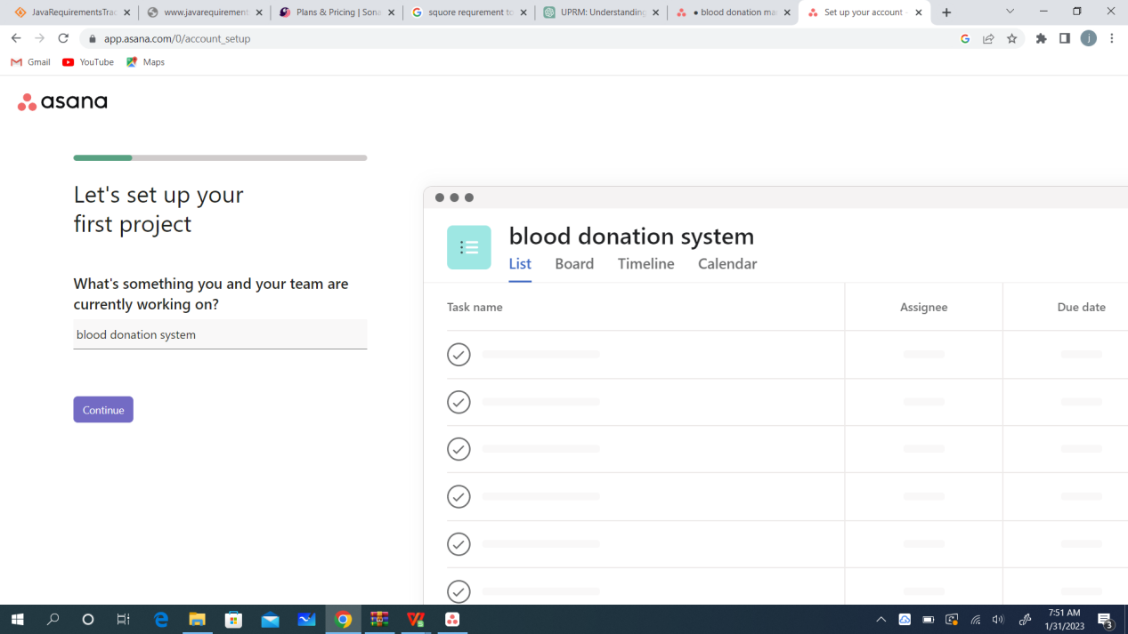

1. list project activities 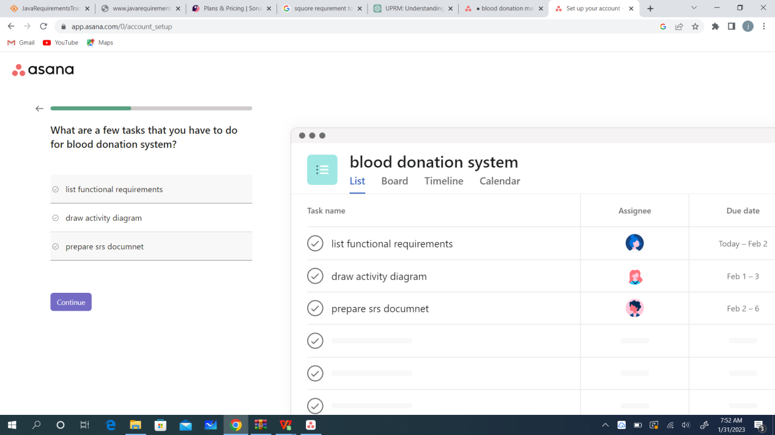
2. Select project layout and usage words

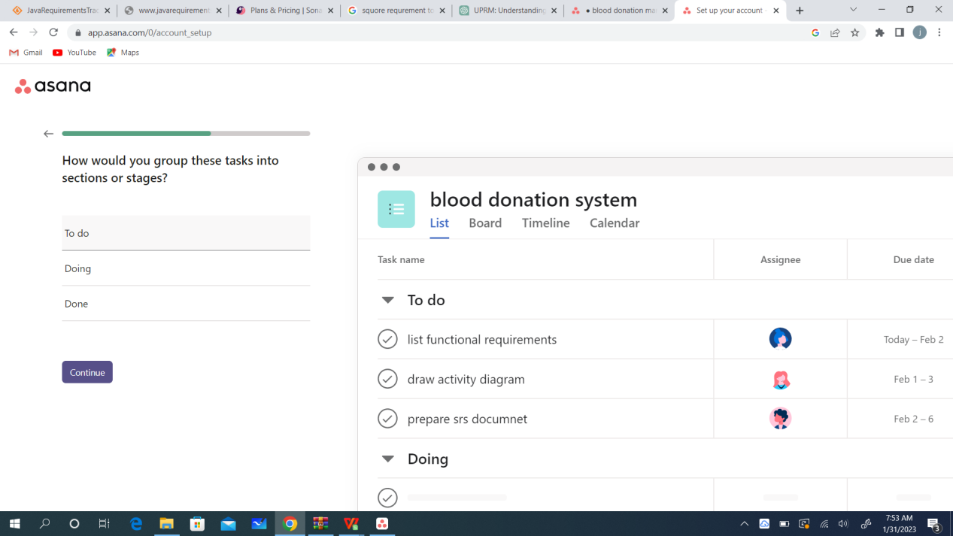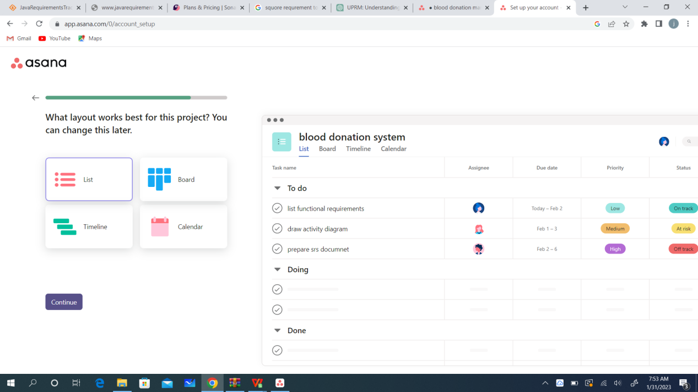

1. enter team member email 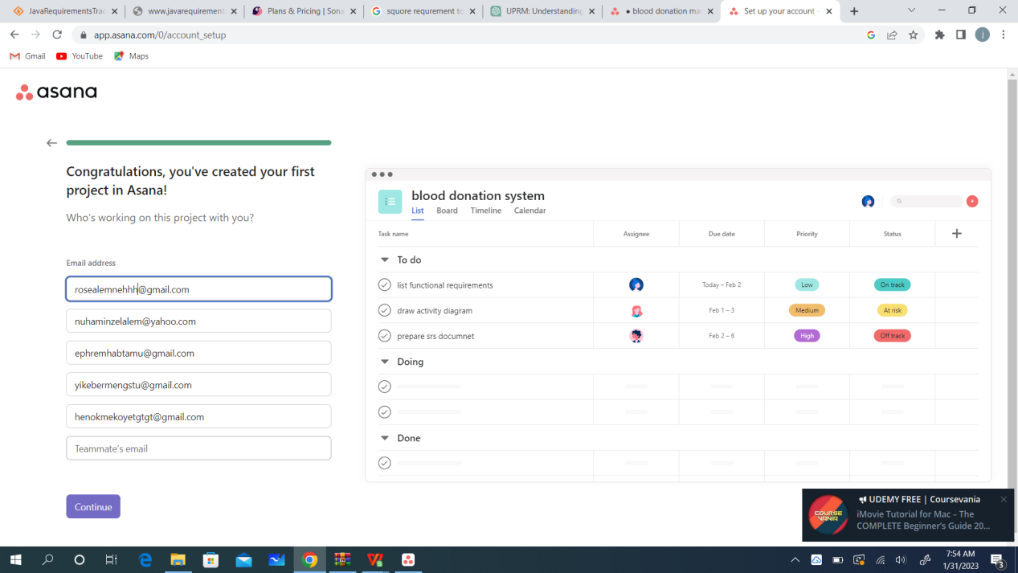
2. Download the android or pc version of asana (optional) 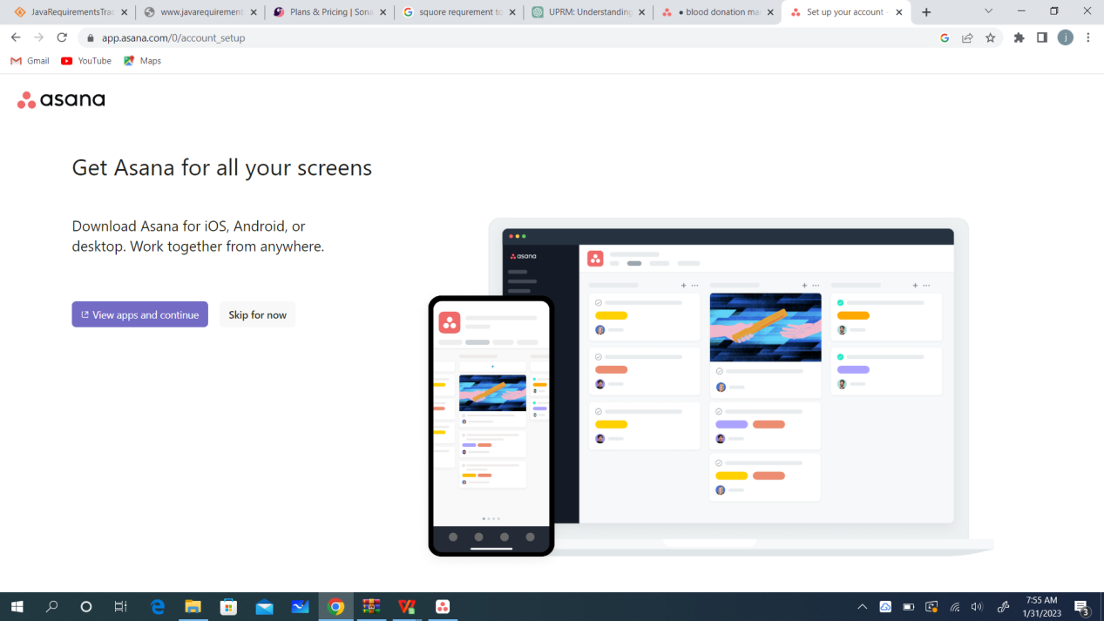
3. Manage your work(assign tasks,set priorities ,add task,check of tasks,set urgency and so on ) 